**Calculator Free**

**Integration, Fundamental Theorem of Calculus, Area**

Time: 45 minutes

Total Marks: 45

Your Score: / 45



**Question One: [2, 2, 2, 2 =8 marks] CF**

1. Calculate 
2. Use your answer to part (a) to evaluate , in terms of *x*
3. Use your answer to part (b) to evaluate 
4. Hence evaluate 

**Question Two: [2, 2, 2 = 6 marks] CF**

Determine each of the following:

1. 
2. 
3. 

**Question Three: [2, 3, 2 = 7 marks] CF**

Consider the function  drawn below over the domain 

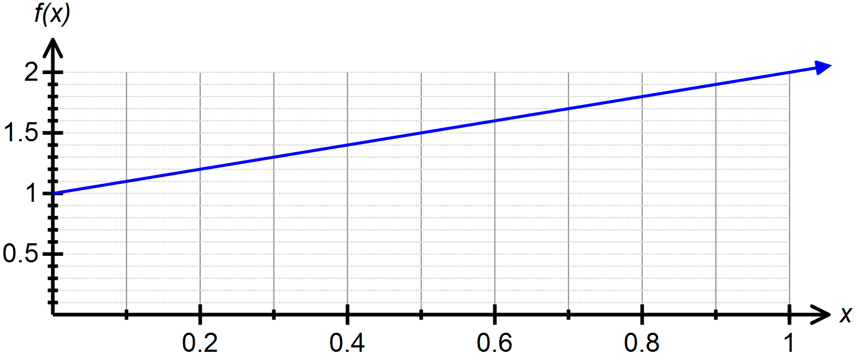

1. Draw rectangles on your graph that can be used to underestimate the area under  over the domain , where .
2. Show that 
3. Use the graph of  above to calculate 

**Question Four: [4, 5 = 9 marks] CF**

Consider the function 

1. Determine the roots of the function.
2. Hence determine the area bounded by the curve and the *x* – axis.

**Question Five: [1, 2, 4 = 7 marks] CF**

The functions  and  are drawn below.

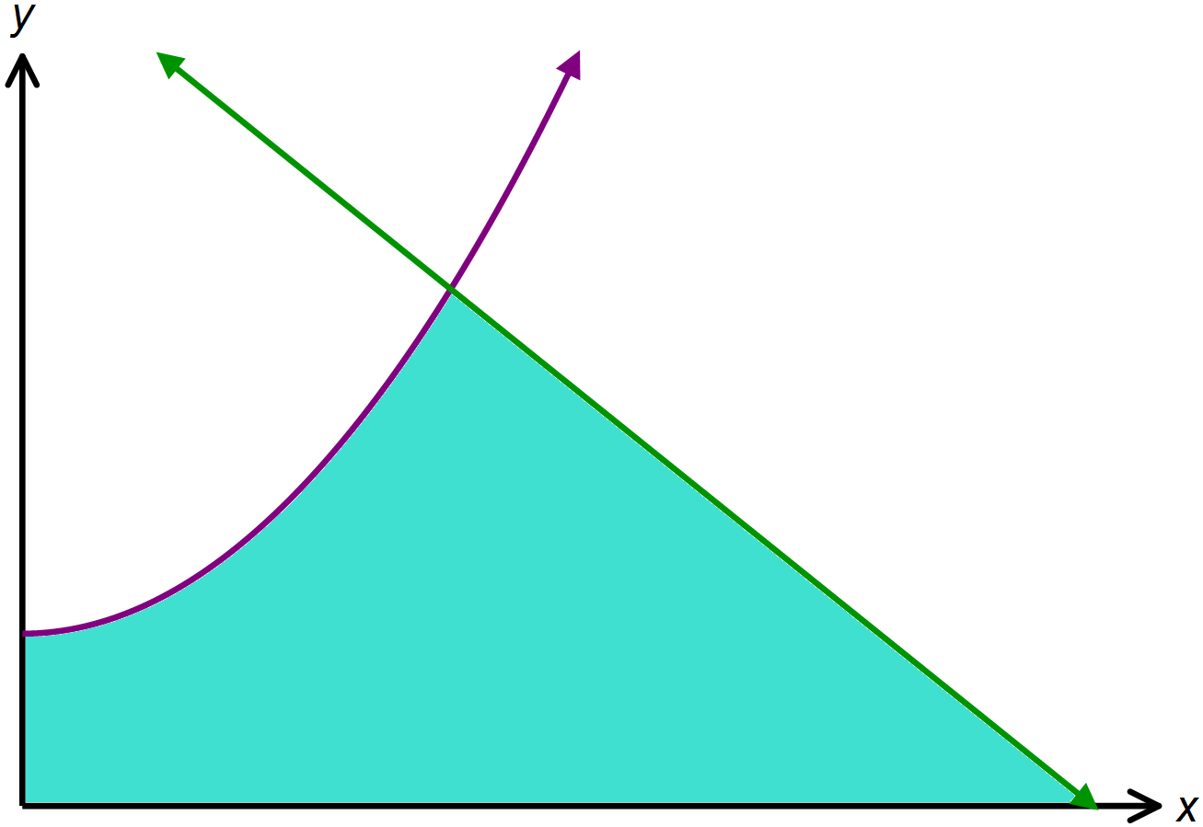

1. Solve 
2. Solve 
3. Hence find the area shaded on the graph above.

**Question Six: [3, 5 = 8 marks] CF**

The curve  and the tangent line at  are graphed below.

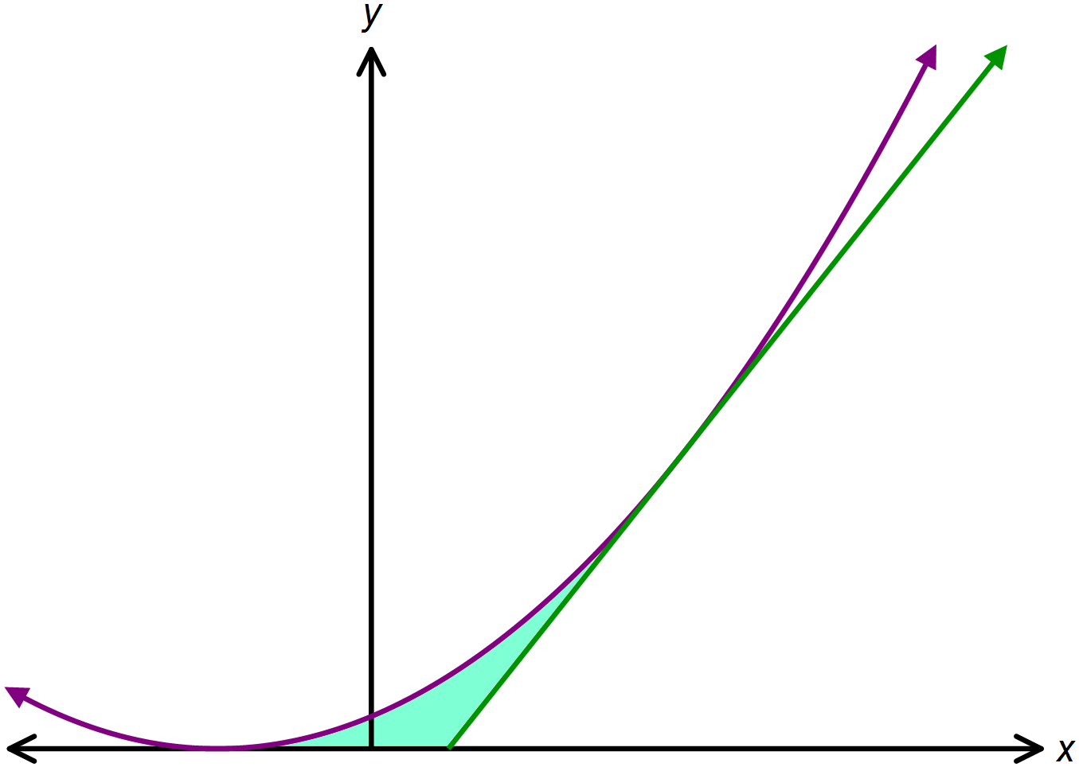

1. Determine the equation of the tangent to  drawn above.
2. Hence find the area shaded on the graph above.

**SOLUTIONS**

**Calculator Free**

**Integration, Fundamental Theorem of Calculus, Area**

Time: 45 minutes

Total Marks: 45

Your Score: / 45



**Question One: [2, 2, 2, 2 =8 marks] CF**

1. Calculate 



1. Use your answer to part (a) to evaluate , in terms of *x*



1. Use your answer to part (b) to evaluate 



1. Hence evaluate 



**Question Two: [2, 2, 2 = 6 marks] CF**

Determine each of the following:

1. 



1. 



1. 



**Question Three: [2, 3, 2 = 7 marks] CF**

Consider the function  drawn below over the domain 

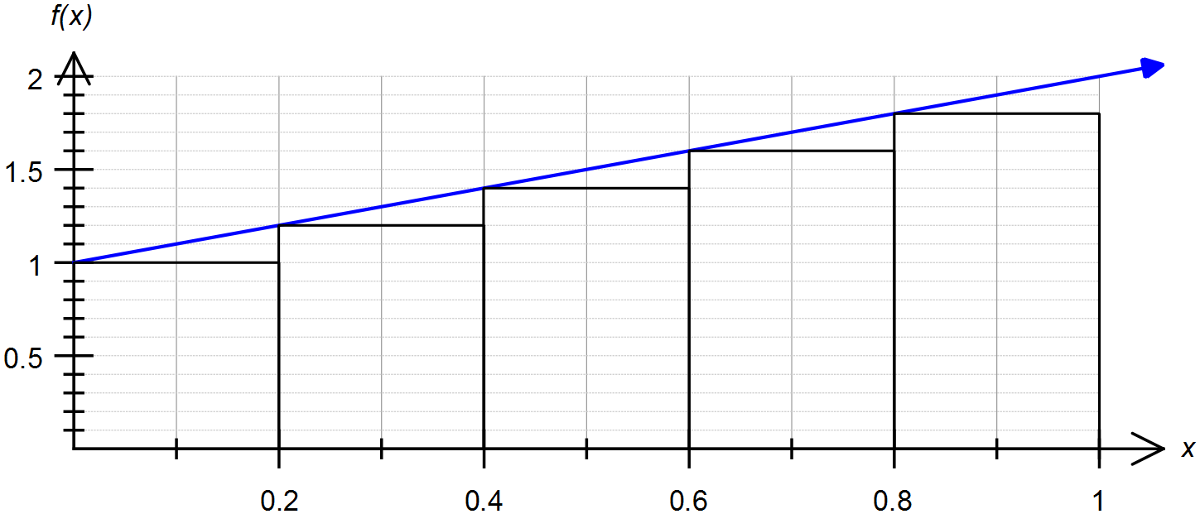



1. Draw rectangles on your graph that can be used to underestimate the area under  over the domain , where .
2. Show that 



1. Use the graph of  above to calculate 



**Question Four: [4, 5 = 9 marks] CF**

Consider the function 

1. Determine the roots of the function.





1. Hence determine the area bounded by the curve and the *x* – axis.



**Question Five: [1, 2, 4 = 7 marks] CF**

The functions  and  are drawn below.



1. Solve 



1. Solve 



1. Hence find the area shaded on the graph above.



**Question Six: [3, 5 = 8 marks] CF**

The curve  and the tangent line at  are graphed below.



1. Determine the equation of the tangent to  drawn above.



1. Hence find the area shaded on the graph above.

